**Decision Table Answer**

Decision table for credit card example:

**[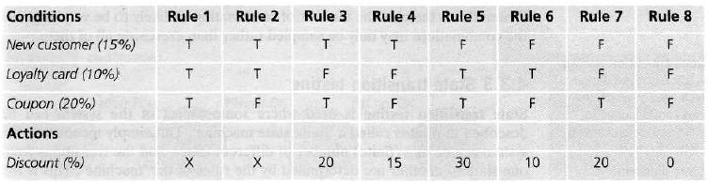](http://istqbexamcertification.com/wp-content/uploads/2012/01/Decision-table-for-credit-card-example.jpg)**

In the table, the conditions and actions are listed in the left hand column. All the other columns in the decision table each represent a separate rule, one for each combination of conditions. We may choose to test each rule/combination and if there are only a few this will usually be the case. However, if the number of rules/combinations is large we are more likely to sample them by selecting a rich subset for testing.

Now let’s see the decision table for credit card shown above:

* Note that we have put X for the discount for two of the columns (Rules 1 and 2) – this means that this combination should not occur. You cannot be both a new customer and also holding a loyalty card as per the conditions mentioned above. Hence there should be an error message stating this.
* We have made an assumption in Rule 3. Since the coupon has a greater discount than the new customer discount, we assume that the customer will choose 20% rather than 15%. We cannot add them, since the coupon cannot be used with the ‘new customer’ discount as stated in the condition above. The 20% action is an assumption on our part, and we should check that this assumption (and any other assumptions that we make) is correct, by asking the person who wrote the specification or the users.
* For Rule 5, however, we can add the discounts; since both the coupon and the loyalty card discount should apply (that’s our assumption).
* Rules 4, 6 and 7 have only one type of discount and Rule 8 has no discount, so 0%.